Twin Tec | Installation Instructions for  TC88A Twin Cam Ignition

CAUTION: CAREFULLY READ INSTRUCTIONS BEFORE PROCEEDING. Not legal for sale or use in California or on any pollution controlled vehicles.

OVERVIEW
A single TC88A part number provides coverage for all 2003-2006 H-D® carbureted models using the new 12 pin ignition module including Twin-Cam and Sportster®. The TC88A offers adjustable advance and adjustable RPM limit settings in 100 RPM increments.
New H-D® motorcycles use the SAE J1850 data bus for communications between the ignition module, instrument cluster and turn signal/security module (TSM/TSSM). The TC88A supports the J1850 data bus.
The TC88A features built-in data logging that stores data for the last 30 minutes of engine operation including RPM, vehicle speed, manifold pressure, ignition advance, and battery voltage. Engine builders will find the data logging feature highly useful for tuning, diagnosing problems, and reducing unjustified warranty claims.
Twin Tec PC link software and an optional USB interface cable (P/N 18014) allow the use of a laptop PC to program a custom advance curve for precise dyno tuning, download data logged by the unit, and access additional features such as speedometer/odometer recalibration (to accommodate tire and gear changes). The USB interface cable plugs into the existing H-D® diagnostic connector on the motorcycle wiring harness.
Figure 1 – TC88A Ignition Module
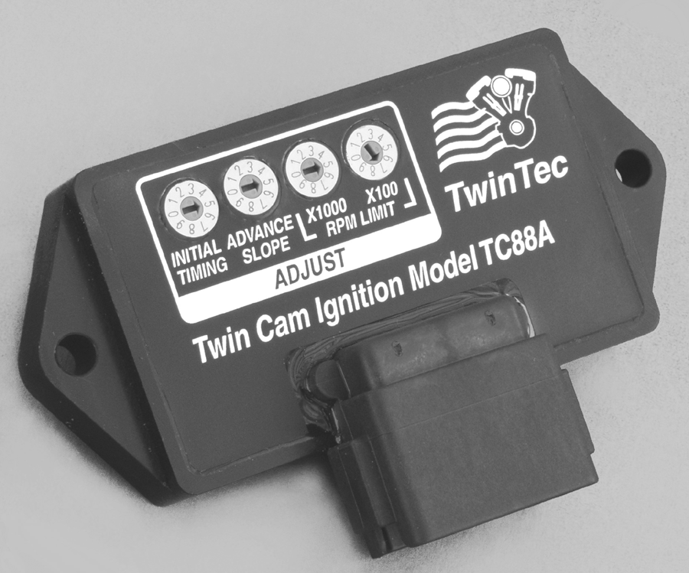

INSTALLATION
- Turn off the ignition switch and disconnect the battery ground cable before proceeding.
- Find and remove the OE ignition module. The OE module is usually located under the seat or under a side cover. You may need to use a small flat screwdriver to press on the connector locking tabs.
- Install the new Twin Tec module. You can reuse the original mounting hardware.
- PC link jumper wire. If you are not planning on using on-bike PC link communications (refer to page 3 for details) you can skip this step. Install the supplied white PC link jumper wire between pin 2 of the ignition module connector (12 pin Deutsch) and pin 1 of the OE diagnostic connector (4 pin Deutsch). Remove and carefully tape up the existing wire on pin 2 of the ignition module connector. Refer to the factory service manual for connector location and disassembly techniques.
- Reconnect the battery ground cable.

RECOMMENDED TIMING SETTINGS
The Twin Cam 88® engine utilizes a non-adjustable crankshaft position sensor. Thus no mechanical means exist for adjusting the timing. The TC88A module overcomes this limitation. The initial timing switch allows you to shift the entire advance table up or down. Switch setting 5 corresponds to nominal timing. Lower switch settings decrease (retard) the initial timing and higher switch settings increase (advance) the initial timing in one-degree steps.
The TC88A module accommodates a wide range of engine applications. The advance slope switch allows you to control the aggressiveness of the ignition advance. Figures 3-5 show the effect of advance slope switch settings. Each figure shows advance curves for various manifold pressure values. Higher switch settings result in more aggressive advance. The effect is more pronounced at high manifold pressures. Note that 30 In-Hg manifold pressure represents wide open throttle (WOT) and 16 In-Hg represents deceleration conditions. Switch setting 5 is similar to the OE advance.
Tuning a particular engine setup always requires some trial and error experimentation, but maximum power is usually obtained by using the highest advance settings possible without audible spark knock. Some recommended starting points are given below:
For stock engines run on normal pump gas (87-89 octane), use initial timing setting 5 and advance slope setting 5.
For stock or mildly modified engines run on 92 or higher octane gas, use initial timing setting 5 and advance slope setting 7.
For high compression engines, use initial timing setting 2 and advance slope setting 2.
If you experience spark knock only at low RPM, you can try reducing the initial timing switch setting while maintaining an aggressive advance slope for maximum power at high RPM by increasing the advance slope switch setting. If spark knock is a problem at high RPM, decrease the advance slope switch setting.
Once you have determined the best switch settings, you can further optimize the timing at a particular RPM or manifold pressure by programming a custom advance curve with our PC Link software and optional interface cable.

RPM LIMITER SETTING
TUNING TIP: Lean air/fuel ratio (AFR) increases the tendency for spark knock. Check AFR and rejet carburetor before optimizing ignition timing. Test the motorcycle on a dyno with an exhaust gas sniffer or use our WEGO.
You can set the RPM limit from 3,000 to 9,900 RPM in 100 RPM increments by means of two rotary switches. The RPM limit is X100 switch setting (i.e. 57 = 5,700 RPM). Inadvertent settings below 3,000 RPM are ignored and result in a 3,000 RPM limit. Setting the RPM limit switches to zero will disable the module.
The TC88A module uses a newly developed RPM limiting algorithm that has been highly optimized for odd firing V twin engines. When the engine is held against the RPM limit, cylinder firing is always paired. This eliminates a torque couple and results in very smooth operation compared to random or sequence type RPM limiters.
Set a safe RPM limit that is appropriate for your engine. Most Twin Cam 88® engines with OE valvetrain components should not be run over 5,700 RPM.

TWIN CAM 88® HOT STARTING PROBLEMS
Some Twin Cam 88® engines are prone to hot starting problems. When cranked after a short hot soak, the engine may “kick back.” Over time, this will cause damage to the ring gear and starter pinion.
The TC88A module uses an improved starting algorithm that includes a programmable cranking delay. The TC88A module is shipped with a zero cranking delay: it fires on the first recognized compression stroke. This works best on stock and mildly modified engines.
High compression engines may exhibit a “dieseling” phenomena after a hot soak. This can be verified by temporarily disconnecting the 3 terminal coil primary connector to disable the ignition. If the engine still kicks back or runs for several revolutions after cranking, the problem is dieseling. The only solution is to install compression releases. When compression releases are installed, best starting results will be obtained by programming the TC88A module for a 1-2 revolution cranking delay. This can be done by means of the PC Link software and optional interface cable.

TACHOMETER CONSIDERATIONS
Like the H-D® OE module, the TC88A sends RPM data to the OE tachometer over the J1850 data bus. TC88A units with firmware revision 2.0 and higher also provide an optional 12 volt square wave tach signal (one pulse per revolution) that is compatible with most tachometers intended for 1999-2003 Twin Cam 88® applications. This allows you to retrofit a wide range of tachometers to newer 2004-2006 models.
Refer to Figure 2 for optional tach hookup. Module pin 2 is used for both PC link communications and the optional tach signal. The PC link can access the module when the ignition is turned on and the engine has not yet been started. Once the engine is started, the tach signal appears. Note that no damage occurs if the engine is inadvertently started while the PC link is still attached.
If you plan to use the optional tach hookup, you must use PC Link TC88 software to enable the tach output. When you enable the tach output, real time data display with TC88A Log software is not available.

GENERAL RECOMMENDATIONS
The TC88A is designed to be used with the H-D® OE coil. Twin Cam 88® engines require a coil with primary resistance less than one ohm. All aftermarket coils intended for Twin Cam 88® engine applications have electrical output characteristics similar to the OE coil and do not offer any particular advantage.
Due to the short lengths involved on motorcycle applications, energy losses in spark plug wires are insignificant. OE carbon core suppression cables will deteriorate after several years. For a more durable replacement, we suggest spiral core type spark plug cables.
CAUTION: Do not use solid copper spark plug cables or non-resistor type spark plugs. The unit may misfire.

CUSTOM BIKE CONSIDERATIONS
At this point in time, most aftermarket companies do not support 2003-2006 models using the new J1850 data bus. If you are building a custom bike with aftermarket instruments, you can connect the speedometer directly to the VSS signal on module pin 10 and the tachometer to the optional tach output on module pin 2. If you need assistance, please contact our tech support department.

COMMUNICATIONS OVERVIEW
The TC88A module supports two types of communications:
J1850 data bus. Used by H-D® for communications between the ignition module, TSM/TSSM (turn signal/security module) and instrument cluster. An automotive industry standard designed for robust communications in a noisy environment, the J1850 data bus is relatively slow and cannot directly interface to a PC.
PC link (RS-232 serial data). Used to interface to a laptop PC running PC Link TC88 or TC88A Log software. RS-232 is a computer industry standard that allows high speed communications.
PC link communications can be used on-bike with the optional USB interface cable (P/N 18014) plugged into the H-D® diagnostic connector (requires installation of the PC link jumper wire as explained in step 4 of the TC88A installation procedure on page 1). If the TC88A unit is removed from the motorcycle, bench top PC link communications requires the use of an optional adapter harness (P/N TC88A-ADAPT) that includes a small 12 volt power supply. Please note that you will still require the USB interface cable.

CUSTOM ADVANCE TABLE
PC Link TC88 software allows you to program a custom advance table, modify certain engine control parameters, and recalibrate the speedometer/odometer. An optional USB interface cable (P/N 18014) is required. For more details, refer to the PC Link TC88 documentation. The latest versions of Twin Tec software and documentation are always available for download on our website. The software is free and will work in demo mode without a TC88A module attached.

SPEEDOMETER/ODOMETER RECALIBRATION
On 2003-2006 models using the new J1850 data bus, the ignition module converts signal pulses from the VSS (vehicle speed sensor) to data that is transmitted to the instrument cluster. Scaling (in terms of VSS frequency/speed) varies slightly between models depending on tire size and gear ratio. The TC88A comes with default scaling that may result in an error of about ±1 MPH at 60 MPH (±1.6 KPH at 100 KPH). You can use PC Link TC88 software to change the default scaling and recalibrate the speedometer/odometer. Refer to the PC Link TC88 documentation for details.

VIN DATA
TC88A Rev 4.1 and later modules can report VIN data on the J1850 data bus. Correct VIN data may be required by some accessories. You can use PC Link TC88 software to program the VIN. Refer to the PC Link TC88 documentation for details.

DIAGNOSTICS AND DATA LOGGING
When the ignition switch is first turned on, the check engine LED illuminates. The LED will go out when the engine is started. If a diagnostic fault is detected, the LED will illuminate.
TC88A diagnostic codes can be read and cleared by means of the speedometer (same as with the OE ECM. Since the TC88A uses the same diagnostic trouble codes as the OE module, you can use the troubleshooting flowcharts in the factory service manual. However, the TC88A is an aftermarket product and its diagnostics are oriented towards performance applications. Rationality check limits are broadened. Some OE diagnostics, such as VSS (vehicle speed sensor) failure and lost data bus communications, are eliminated to provide compatibility with custom bike applications that may not include all of the OE sensors, TSM/TSSM (turn signal/security module), and instrument cluster. For maximum hardware fault coverage, we suggest that you reinstall the OE module during diagnosis.
The TC88A features built-in data logging that stores data for the last 30 minutes of engine operation including RPM, vehicle speed, manifold pressure, ignition advance, and battery voltage. Engine builders will find the data logging feature highly useful for tuning, diagnosing problems, and reducing unjustified warranty claims. An optional USB interface cable (P/N 18014) and TC88A Log software are required to access the data logging feature. TC88A Log software also allows you to view engine data in real time and display operating statistics and historical diagnostic codes. For more details, refer to the TC88A Log documentation. The latest versions of Twin Tec software and documentation are always available for download on our website. The software is free and will work in demo mode without a TC88A module attached.

KNOWN ISSUES
The TC88A module can be upgraded in the field by the user. Operating firmware is stored in FLASH memory and new firmware can easily be uploaded by means of the PC link cable. We suggest you periodically check our website at www.daytona-twintec.com for upgrades to the TC88A firmware and accompanying PC based software.
The TC88A system is new to the marketplace and as with all complex new computer systems, unforeseen issues may occur. As of the shipment date, there are no known issues other than those listed.
TSSM module trouble code. Installation of the TC88A may set a TSSM module trouble code. This may cause the turn signals to momentarily blink and the security LED to light up for several seconds when the engine is started. The turn signals and security system will continue to function normally.
Possible firmware corruption during dyno test. We suggest that you do not connect the PC link cable to any PC running Dynojet WinPEP software. Use a separate PC, such as a laptop with isolated ground. There appears to be a serial port conflict or noise issue from the Dynojet ignition pickup.

REINSTALLING THE OE MODULE
You can temporarily reinstall the OE ignition module without concern for the PC link jumper wire (step 4 of the TC88A installation procedure on page 1). However, if you plan to permanently remove the TC88A, you should also remove the PC link jumper wire and restore the original connections.

TROUBLESHOOTING FLOWCHART
Follow the troubleshooting flowchart on page 7. Experience has shown that most units returned for warranty are OK and another problem, such as a defective coil or user error, is later identified.

Figure 2 – Wire Diagram
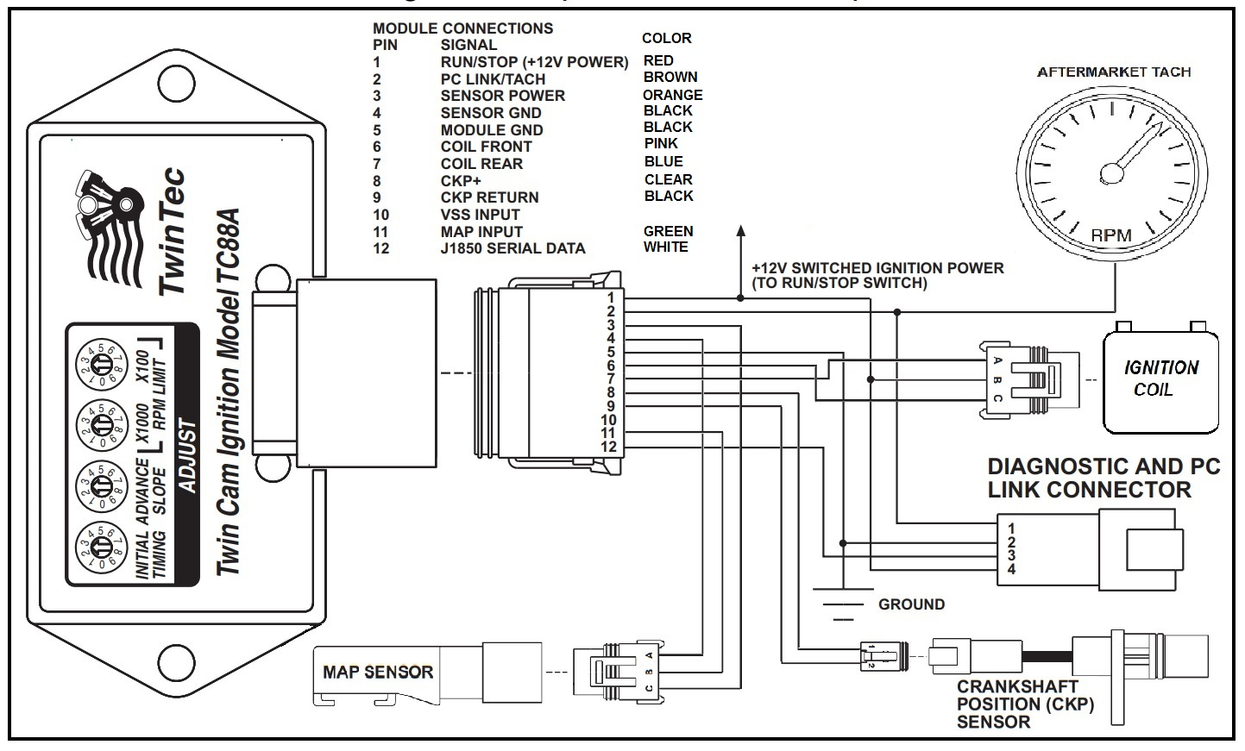
Figure 3 - Graph Representing Advance Slope Setting 0 (Least Aggressive)
Figure 4 - Graph Representing Advance Slope Setting 5 (Nominal)
Figure 5 - Graph Representing Advance Slope Setting 9 (Most Aggressive)
Troubleshooting Flowchart

